🎯 **Goal:**

Download monthly weather data for **June, July, and August** *(2012–2022)*.

🌐 **Website:**

[Climate Weather Canada Monthly Summaries](https://climate.weather.gc.ca/prods_servs/cdn_climate_summary_e.html)

* Select **Ontario**
* Select the year and month
* Be mindful to **only download June–August data  
  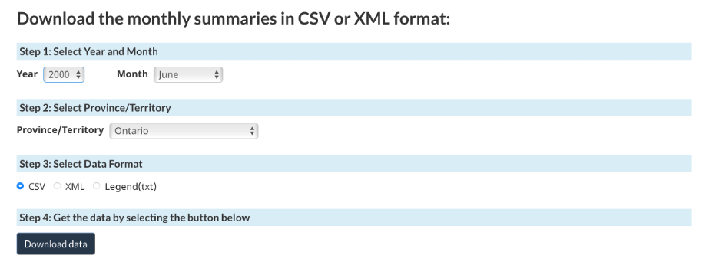**

📑 **Fields to Retain (columns):**

* **Tm:** Mean Temperature (°C)
* **Tx:** Max Temperature (°C)
* **Tn:** Min Temperature (°C)
* **S:** Total Rainfall (mm)
* **P:** Total Precipitation (mm)
* **CDD:** Cooling Degree Days

🗂️ **File Naming Convention:**

[Year]_[Month]_Ontario.csv

*(Example: 2010_June_Ontario.csv)*

⚙️ **Process:**

1. Download the full Ontario CSV for each target month/year.
2. Keep **only rows for our target stations**.
3. Retain **only the columns listed above**.
4. Save as clean CSV files for merging later.

✅ **Expected Output:**

A **single merged CSV file** containing all selected stations, with records from **June, July, and August (2012–2022)** combined in **one table**, ready to be used for ML model input.

💡 **Note:**

If any column is missing for a month, **leave it blank (NA)**—we’ll handle missing values in Pandas.